3G186R-How to setup this 3G router?
Product line: 3G Question category: Internet settings

Steps as follows:
1. Go to 3G186R manage page and click Advanced


2. Quick Setup->Next
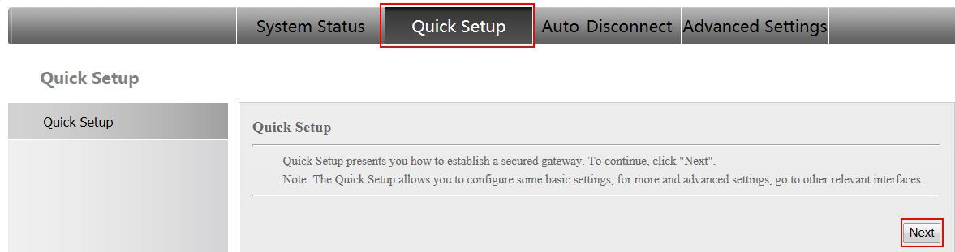
3. Auto APN OR Manual APN→Next
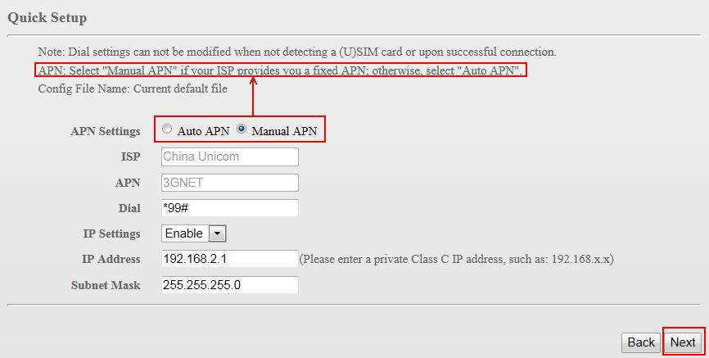
4. Next

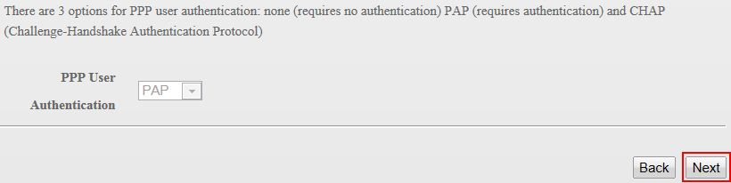
5. choose connect type→next 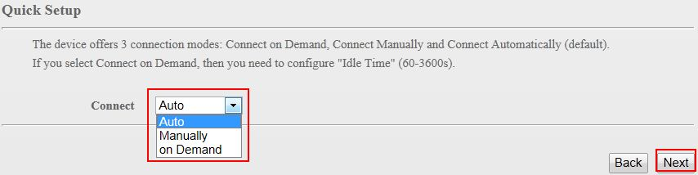
6. You can change the SSID→next
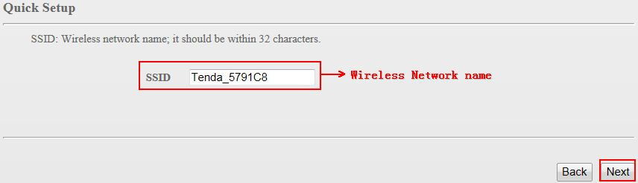
7. You can change the security key→next
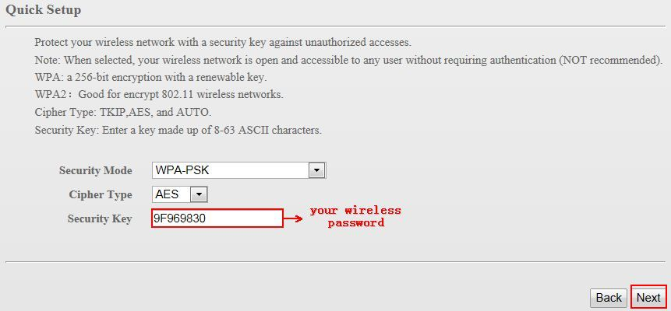
8. After click save. 3G186R will reboot and you have to reconnect your WIFI 